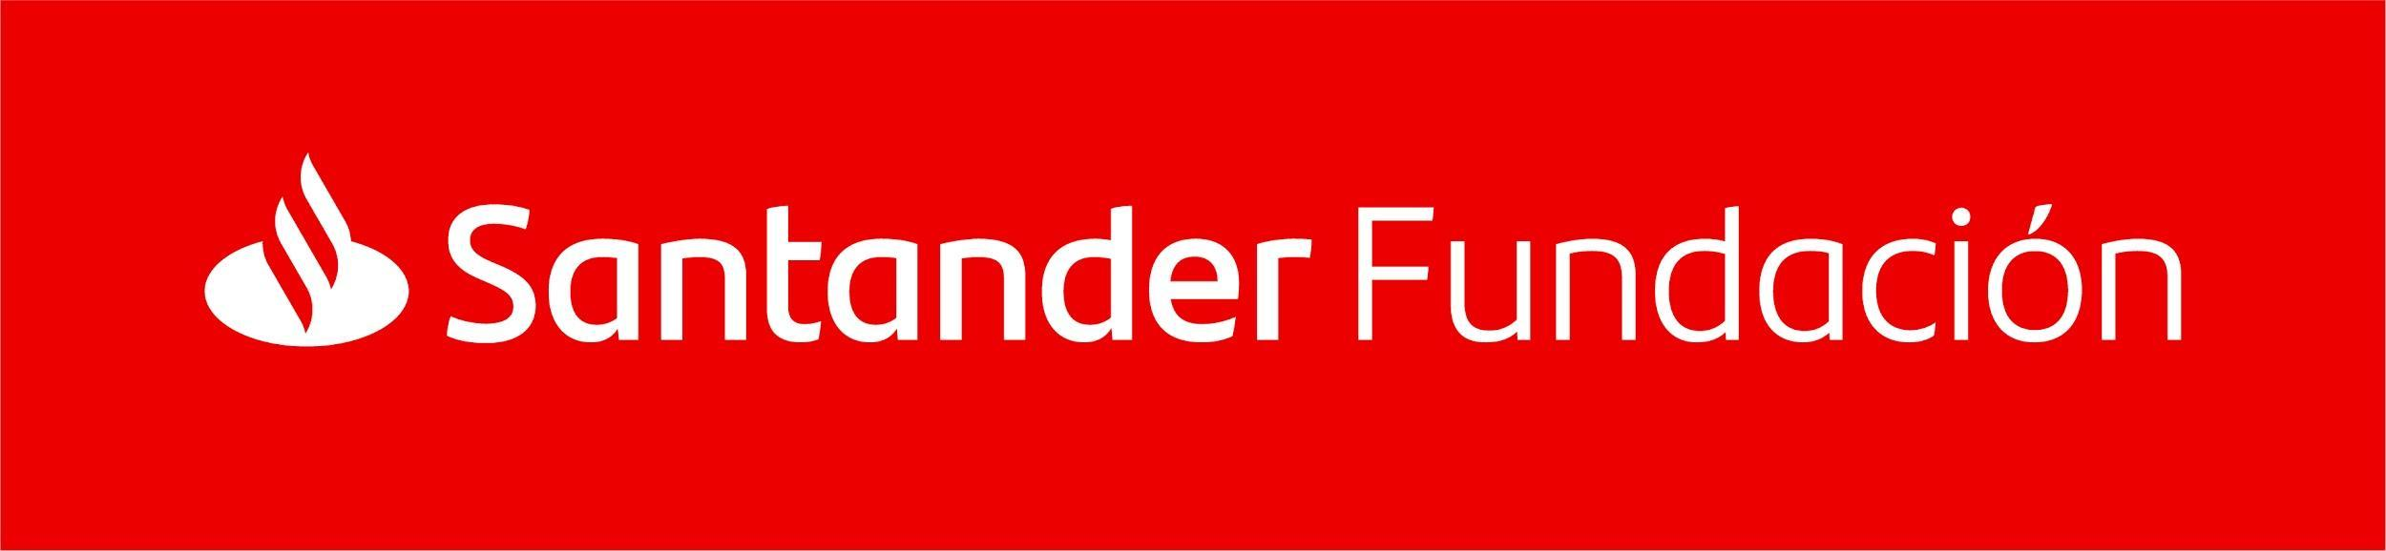

SRUK EMERGING TALENT AWARD 2021 Application form

Personal data
NAME
SURNAME(S)
DNI/PASSPORT
NATIONALITY
DATE OF BIRTH dd/mm/yyyy
ADDRESS
TELEPHONE NUMBER
E-MAIL

Research area

☐ Biomedical Research
☐ Biotechnology & Biological Sciences
☐ Chemistry
☐ Engineering & Computer sciences
☐ Environmental Sciences
☐ Mathematics & Physical Sciences

PhD
UNIVERSITY WHERE PhD DEGREE WAS OBTAINED:
DATE OF PhD AWARD:

Research activity from your PhD (add more rows if needed)
1 | RESEARCH CENTRE
POSITION (postdoctoral researcher,
principal investigator, etc.)
 | JOB START AND COMPLETION DATES
2 | RESEARCH CENTRE
 | POSITION
 | JOB START AND COMPLETION DATES
3 | RESEARCH CENTRE
 | POSITION
 | JOB START AND COMPLETION DATES

Referee (senior researcher in applicant’s field)*
NAME AND SURNAME(S)
POSITION
RESEARCH CENTRE
TELEPHONE NUMBER
E-MAIL
*The referee may be contacted if further information is needed after the shortlisting.

In case of a career break (maternity or paternity leave, adoption, serious sickness, caring responsibilities, etc.), please indicate
REASON
START AND COMPLETION DATES

*The following documents need to be attached to this form:

- A report explaining the candidate’s most important achievements in his/her research career (maximum 2 pages A4, font Arial 11, 2 cm margin).
- Motivation letter (maximum 2 pages A4, font Arial 11, 2 cm margin) in which the end use of the award (research, dissemination, training, help for family-working life balance…) and the impact of the award in the development of the candidate’s research career will be explained.
- Curriculum vitae (maximum 4 pages).
- Nomination form (only in case of a nomination).
- Documentation to Support paternity, sick or any other leave taken

